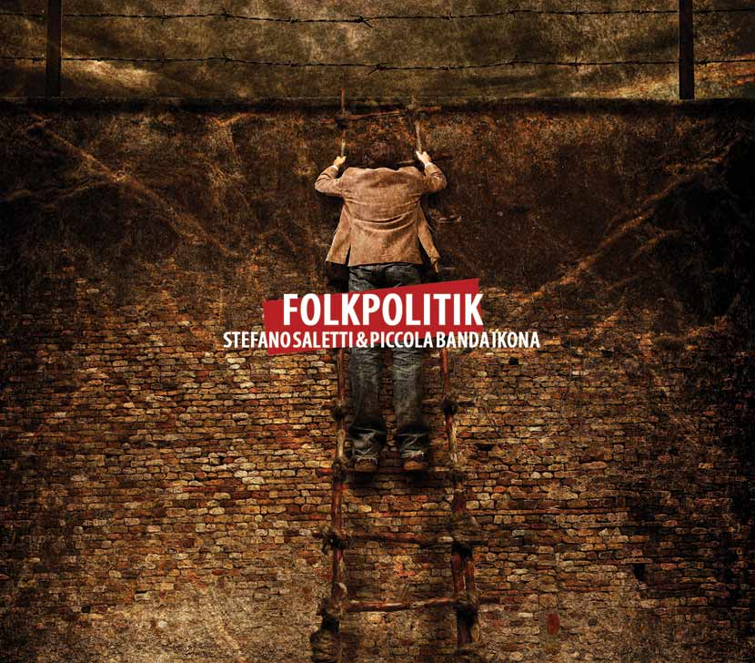
FOLKPOLITIK

By Stefano Saletti and the Piccola Banda Ikona
the songs of the Mediterranean: from Spring Arab authors persecuted by the regimes of Spain, Portugal and Greece

“The sights and sounds of the Arab Spring arriving from the streets of Tunis, Cairo and Damascus, make the mind retun to the 1970's, when Europe was crossed by a wind of freedom that swept away the authoritarian regimes in Spain, Greece and Portugal. Those squares are the same: the same faces, hopes, colours, sounds, songs. A struggle for freedom that today ideally combines the two shores of the Mediterranean and further demonstrates the strength of popular music as the voice of the people. In joy and in defeat”.

This Stefano Saletti writes to describe his new album with the Piccola Banda Ikona titled "Folkpolitik" (to be published by Finisterre and distributed by Felmay), which, along with original compositions, are rearranged tunes by the Mediterranean and have told in music the struggle against power, suffering persecution, arrests, violence.
A journey back in time to rediscover the different types of music that tell the stories about the suffering and passion of the Mediterranean people. From the expulsion of the Sephardic Jews from Spain, to the Palestinian diaspora, from the Sardinian anthem (fruit of the French Revolution against the excessive power of the barons) to those authors who had written music and often very sweet ballads and who were subjected to persecution, arrest and violence by the political powers that be.

Multi-instrumentalist, an expert on music of the Mediterranean and director of international ensembles, Saletti is the founder of the Piccola Banda Ikona, a group that has within it famous musicians such as singers Barbara Eramo and Ramya, the wind instruments player Gabriele Coen, the violinist Carlo Cossu, the bassist Mario Rivera and the drummer Leo Cesari.
Rounding out the band's sound also special guests such as Ambrogio Sparagna and violinist Jamal Ouassini.

The Piccola Banda Ikona in his original compositions sung in Sabir, a lingua franca which sailors, pirates, fishermen, merchants, ship-owners used in the ports to communicate with each other: from Genoa to Tangiers, from Salonika to Istanbul, from Marseilles to Algiers, from Valencia to Palermo, until the early decades of the twentieth century this kind of sea-faring “Esperanto” developed little by little availing of terms from Spanish, Italian, French and Arabic.

The previous CD "Marea cu Sarea" has been included among the ten best new issues in the Folk Roots chart, the prestigious English world music magazine, and had been listed as one of the best releases of 2008 by the World Music Charts Europe and received the “Coups de coeur du jury” award at Babel Med 2009.
During last years Stefano Saletti and the Piccola Banda Ikona toured extensively in some of major international festival in Italy, Portugal, Spain, France, Bosnia-Erzegovina, Maroc, Hungary, Greece, Egypt and Germany.
Their first cd, issued on 2005, "Stari Most" was dedicated to the historical bridge in Mostar (Bosnia) that was bombed in 1993 and which has always represented a symbol of the meeting and passage between East and West
Numerous collaborations by Saletti and the Piccola Banda Ikona with writers and theater directors in national and international tours.

LINE UP:

Stefano Saletti: bouzuki, oud, guitar, vocals
Barbara Eramo: vocals
Ramya: vocals
Gabriele Coen: clarinet, bass clarinet, sax, flute
Carlo Cossu: violin
Mario Rivera: acoustic bass
Leo Cesari: drums and percussion

with:
Ambrogio Sparagna: organetto
Jamal Ouassini: violin

Contacts:
info@piccolabandaikona.it
info@finisterre.it

web:
www.piccolabandaikona.it
www.myspace.com/piccolabandaikona
www.finisterre.it
www.felmay.it

press office:
Fabiana Manuelli: fabianamanuelli@gmail.com

